KENDRIYA VIDYALAYA PANCHGRAM
HOLIDAY HOMEWORK
Summer Vacations 2020-21
CLASS VI
ENGLISH | Write a paragraph about yourself from any point of view, or choose one of the following topics.  a. What I enjoy doing most  b. What makes me angry  c. What I hate to do  d. What I want to do  2. Write the summary of the poem” do all the Teachers Go?”  3. Write a paragraph on the Desert Animals.  4. Imagine you are journeying through a desert. Write a paragraph describing what you see and hear.  5. Recite any of the poem of your textbook and make a video on it.
HINDI | 1 अस्वस्थ होने के कारण दो दिन की छुट्टी के लिए प्राचार्य को प्रार्थना पत्र लिखिए  2 आपने शीतकालीन अवकाश कैसे बिताया विषय पर 100शब्दों में लिखिए  3 दस पेज सुलेख करिए  4 निम्नलिखित शब्दों के पर्यायवाची शब्द लिखिए तथा याद करिए  फूल, जल , सूर्य, बादल, रात
MATHS | - Exercise 10.1 page no. 213 – Question No. 11 to16.  - Exercise 10.3 page no. 219 – Question No. 4 to10.  - Exercise 11.1 page no. 227 – Question No. 7 to10.  - Exercise 11.3 page no. 233 & 234 – Question No. 4 and 5.  - Exercise 11.4 page no. 235 – Question No. 1.  - Exercise 8.3 page no. 175 – Question No. 1 (a to j).  - Exercise 8.5 page no. 179 – Question No. 2,3,4.  - Draw rectangle, square,triangle,Hexagon,Pentagon,Octagon and write down its perimeter and area.  - Revise and practice the following chapters  - Fraction b. Decimal c. Mensuration d. Algebra.
SST | Solve 2 worksheets provided in notebook.
SCIENCE | Q1. What is conductor, Insulator, Switch, Battery.  Q2. What is the purpose of using an electric switch ? Name some electrical gadgets that have switches built into there.  Q3. The handle of tools like screwdrivers and pliers used by electricians for repair work usually have plastic or rubber covers on them. Can you explain why ?  Q4. What are different properties of magnet ?  Q5. How is a compass used to find direction ?  Q6. Draw different types of magnet ?  Q7. What is water cycle.Explain it ?  Q8. Write about uses of water ?  Q9. What are the different sources of water ?  Q10. How are clouds formed ?  Q11. Draw a diagram of water cycle in chart paper (A4 size) and colour it properly.  Q12. Define about coloud, condensation, evaporation, rainwater harvesting, water vapour, transpiration.  Q13. Draw inside diagram of a torch.
SKT | 1 संस्कृत में 1 से 50तक गिनती लिखिए तथा याद करिए ।  2 शब्द रूप-बालक, बालिका तथा फल लिखिए तथा याद करिए ।  3 चार श्लोक लिखिए तथा याद करिए  4 दस फलों और सब्जियों के नाम संस्कृत में लिखिए ।
WE | Make Greetings card, Folder
LIBRARY | - Children’s Illustrated Dictionary - Students, read this Dictionary and later on interesting quiz, puzzles, crossword etc. will be given based on this dictionary.  -Link of this dictionary is already given in Google Classroom. Link of quiz, puzzles, crossword etc. will be given in the Class Whatsapp Group later on.  - Know India- https://knowindia.gov.in – Students, you will find important information regarding our motherland India, which is the sole responsibility of us to be an awakened citizen of India.  -Link of this dictionary is already given in Google Classroom. Link of quiz, puzzles, crossword etc. will be given in the Class Whatsapp Group later on.  Quiz on Mixed Subjects like Education, Science, Language, Culture, Art, Sports etc. for all classes.

CLASS VII
ENGLISH | 1.Write an interesting story in your own words on any one topic of your choice . ( Topic - The Bear story, The Quality, The Invention of vita Wonk )  2.Write an article on any one of the topics- use of mobile phone among teenagers , My aim in life, save the planet Earth.  3. Write a letter to the editor about the increasing use of mobile games among children.  4.Learn and revise all the chapters as per split up syllabus for Periodic Test 2.  5. Read English newspaper and write two difficult words with their meaning each day.  6. Practice Adjectives ,Determiners ,articles conjunction. (10 fill in the blanks each)  7.Make a poster on any of the following topics :  a)Precautions regarding Covid -19  b)Donate blood .  c)Keep the earth green .  d)Save girl child.
HINDI | 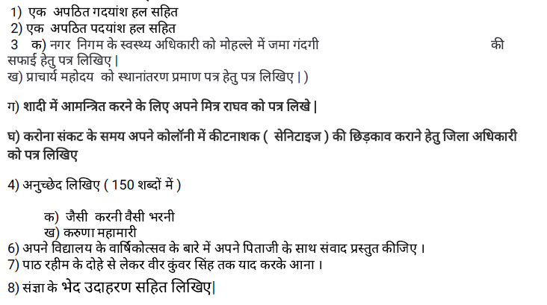
MATHS
SST | Solve worksheet provided in notebook.
SCIENCE | - Make a disc with seven colors.  - Make a Map of showing different monsoon states in India.  - Exercise questions to be solved from the chapter -Water, a precious resource.
SKT | 1 चार श्लोक लिखिए तथा याद करिए ।  2 संस्कृत में 1 से100 तक गिनती लिखिए तथा याद करिए ।  3 धातु रूप- पच्, वस्, दृश् ,पा लिखिए तथा याद करिए ।  4 शब्द रूप- वारि,नदी, मति लिखिए तथा याद करिए ।
WE | Make a decorative port using shilpker and colours.
LIBRARY | - Children’s Illustrated Dictionary - Students, read this Dictionary and later on interesting quiz, puzzles, crossword etc. will be given based on this dictionary.  -Link of this dictionary is already given in Google Classroom. Link of quiz, puzzles, crossword etc. will be given in the Class Whatsapp Group later on.  - Know India- https://knowindia.gov.in – Students, you will find important information regarding our motherland India, which is the sole responsibility of us to be an awakened citizen of India.  -Link of this dictionary is already given in Google Classroom. Link of quiz, puzzles, crossword etc. will be given in the Class Whatsapp Group later on.  Quiz on Mixed Subjects like Education, Science, Language, Culture, Art, Sports etc. for all classes.

CLASS VIII
ENGLISH | 1.Write interesting story on any one topic of your choice.  2.Write an article on any one of the topics- use of mobile phone among teenagers , My aim in life, save the planet Earth.  3. Write a letter to the editor about the increasing use of mobile games among children.  4.Learn and revise all the chapters as per split up syllabus for Periodic Test 2.  5. Read English newspaper and write two difficult words with their meaning.  6. Practice determiners ,articles and conjunction. (10 fill in the blanks each)  7.Make a poster on any of the following topics :  - Donate blood  - Keep the earth green  - Save girl child
HINDI | 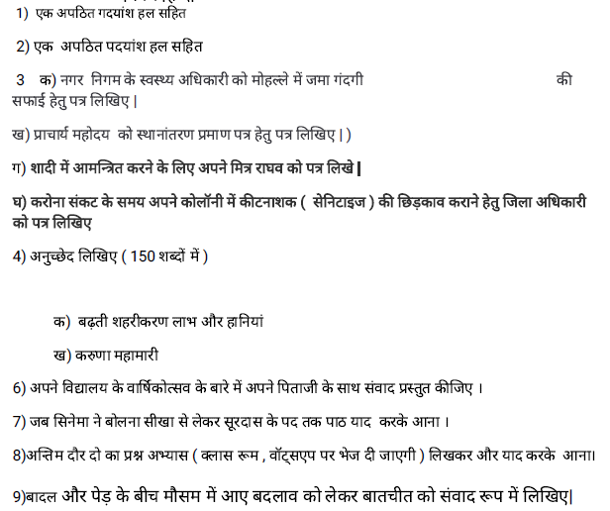
MATHS | - Complete the Art integrated Project & Art integrated Learning activity .  - Complete your class notebook .  - Practice all the exercises & test papers uploaded till date in Google classroom keeping in view of upcoming Exam.  - Complete the PISA practice items .
SST | 1. ART INTEGRATED ACTIVITY (4.1.6.1) - make an assignment on role of women ,caste and other important cultural aspects in Rajasthan during British rule and at present time.  2. Map work- Locate different types of industries like iron and steel industries and IT industries.  3. Learn and write ch-5 Industries, ch-6 understanding our criminal system, ch-8 civilizing the native and educating the world and ch-9 women ,caste and reforms.
SCIENCE | - Exercises questions to be solved from the chapter – Stars and the Solar system.  - Observe the moon continuously for several nights, preferably from one full moon to the next. Make a sketch of the moon every night in your notebook and note the day from the day of the full moon. Also note every day the part of the sky (east or west) in which the moon is seen.
SKT | 1 संस्कृत में 1से 100तक गिनती लिखिए तथा याद करिए ।  2 शब्द रूप- अस्मद्, युष्मद् तथा किम् लिखिए तथा याद करिए  3 चित्र वर्णन  4 अपठित अवबोधनम्
WE | Make series and parallel connection using three numbers of bulbs, holder and switch
LIBRARY | - Children’s Illustrated Dictionary - Students, read this Dictionary and later on interesting quiz, puzzles, crossword etc. will be given based on this dictionary.  -Link of this dictionary is already given in Google Classroom. Link of quiz, puzzles, crossword etc. will be given in the Class Whatsapp Group later on.  - Know India- https://knowindia.gov.in – Students, you will find important information regarding our motherland India, which is the sole responsibility of us to be an awakened citizen of India.  -Link of this dictionary is already given in Google Classroom. Link of quiz, puzzles, crossword etc. will be given in the Class Whatsapp Group later on.  Quiz on Mixed Subjects like Education, Science, Language, Culture, Art, Sports etc. for all classes.

CLASS IX
ENGLISH | - Collect information about the sports personality you like most and write a Bio-Sketch.  - Listen to the the song 'Imagine' by John Lennon and write down the lyrics. Then compare the message given by the song with the poem, “No Men are Foreign” from your text.  - Make a collage collecting information about recent cyclone hit in any place of the world. Then, write an article on how we can help each other during such calamities.
HINDI | 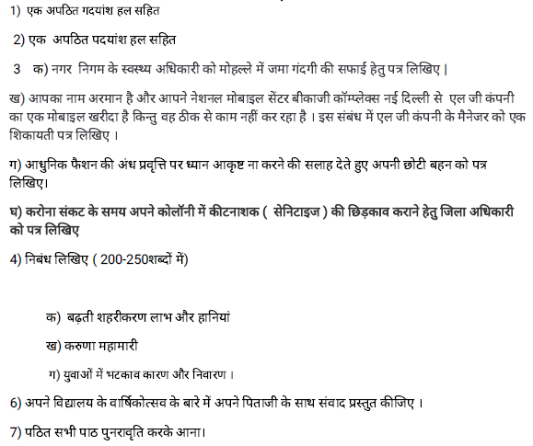
MATHS | - Complete the Art integrated Project & Art integrated Learning activity .  - Complete your activity record & class notebook .  - Practice all the exercises & test papers uploaded till date in Google classroom keeping in view of upcoming PT -3 Exam.  - Complete the PISA practice items
SST | Solve the sample paper provided in your notebook.
SCIENCE | - Completion of Practical /Activity work.  - Complete all the class written work.  - Practice of NCERT Numericals whole of syllabus.  - Art Integrated project assigned to the students.  - Sample paper to be solved by the students.
SKT | 1 अपठित अवबोधनम्  2 पत्र लेखनम्
WE | Make a simple electric circuit.
LIBRARY | - Children’s Illustrated Dictionary - Students, read this Dictionary and later on interesting quiz, puzzles, crossword etc. will be given based on this dictionary.  -Link of this dictionary is already given in Google Classroom. Link of quiz, puzzles, crossword etc. will be given in the Class Whatsapp Group later on.  - Know India- https://knowindia.gov.in – Students, you will find important information regarding our motherland India, which is the sole responsibility of us to be an awakened citizen of India.  -Link of this dictionary is already given in Google Classroom. Link of quiz, puzzles, crossword etc. will be given in the Class Whatsapp Group later on.  Quiz on Mixed Subjects like Education, Science, Language, Culture, Art, Sports etc. for all classes.

CLASS X
ENGLISH | - Visit the link and solve the Sample Paper for English Language and Literature.  https://drive.google.com/file/d/10tv592JATzoowEccKUsXR4QHKtEEBoGL/view?usp=sharing
HINDI
MATHS | - Complete the Art integrated project and Art integrated learning .  - Solve the sample papers uploaded in Google classroom.  - Solve all the test papers uploaded in Google classroom.  - Practice Previous year question papers of 2019-20. (Both basic & standard) in homework copy.
SST | - Solve the sample papers provided in your notebook.  2. On an outline Political Map of India, locate and label / Identify the following:-  A. Indian National Congress Sessions:-  • Calcutta (Sep. 1920)  • Nagpur (Dec. 1920)  • Madras (1927)  • Lahore (1929)  B. Important Centres of Indian National Movement  (Non-cooperation and Civil Disobedience Movement)  • Champaran (Bihar) Movement of Indigo Planters  • Kheda (Gujarat) Peasant Satyagrah  • Ahmedabad (Gujarat) Cotton Mill Workers Satyagraha  • Amritsar (Punjab) JallianwalaBagh Incident.  • ChauriChaura (U.P.) calling off the NCM.  • Bardoli (Gujarat) no tax campaign  • Dandi (Gujarat) Civil Disobedience Movement  POLITICAL SCIENCE: - 1. On the basis of reading Chapter-2 of Political Science i.e.  “Federalism”, make at least 20 additional questions covering the whole chapter and  solve them in the fair notebook of Political Science.(10 Very Short Answers, 6 Short  Answers and 4 Long Answers).  GEOGRAPHY and ECONOMICS: - 1. Prepare a project on the given topic -Forest and  Wildlife resource in India (Maximum pages-20).  2. Mark and label the following on the political map of India:-  (a) Technology parks in India (b) Sea ports and air ports in India  (c) Dams in India (d) Power plants in India  (e) Iron and steel industries in India (f) Cotton textiles industries in India  3. Learn all the questions and answers of the completed chapters.
SCIENCE | - Completion of Practical Activity work.  - Download Science sample paper papers from CBSE website and practice at least 3 sample papers.  - Practice Numerical of Ch- Light reflection and refraction, Electric Current, heating effect of current  - Sample paper to be solved by the students.  - Art Integrated project assigned to the students.  Chemistry  - Why graphite is good conductor of electricity but diamond is bad conductor of electricity?  - Classify the following compounds in alkanes, alkenes and alkynes.  C₂H₆, C₁₀H₂₀, C₁₅H₃₂, C₇H₁₂, C₅H₁₂  - Chlorine, Bromine and Iodine forms Dobereiner’s triad. The atomic masses of Chlorine and Iodine are 35.5 and 126.9 respectively. Predict the atomic mass of Bromine.  - How are the positions of isotopes decided in the modern periodic table?  - Explain how atomic sizes vary along the period and down the group in modern periodic table.  - What is electronegativity of elements? How electronegativity of elements vary along the period and down the group in modern periodic table.
SKT | 1 आदर्श प्रश्न-पत्र  2 पत्र लेखनम्  अपठित अवबोधनम्
WE | Make a switch board controlling of two numbers of three pin socket with two numbers of switches
LIBRARY | Book Review of the famous novel of all time: Gulliver’s Travels by Jonathan Swift. Link of Book Review will be given in Class Whatsapp Group  Quiz on Mixed Subjects like Education, Science, Language, Culture, Art, Sports etc. for all classes.

CLASS XII
ENGLISH | - Visit the link and solve the Sample Paper for English Core.  https://drive.google.com/file/d/1NhcUmKYqw3cL5DzWwmgM06RTuPdEFQxW/view?usp=sharing
HINDI
MATHS
PHYSICS | - Completion of Practical writing work and fill all the readings that have been completed  - Completion of Practical Activity work.  - Practice of Last 5 Year sample Board Question papers latest pattern.  - Practice of NCERT Numerical of Chapter 1 to 14.
BIOLOGY | - Sample paper to be solved by the students.  - Project work to be given.
CHEMISTRY
ECONOMICS | 1. ART INTEGRATED ACTIVITY (4.5.3.2) - Chart tabulation of census data and other aspects like music, costume, language etc. of Rajasthan.  2. Read, learn and solve the sample papers (uploaded in Google classroom) in class notebook.  3. Learn and solve Mcqs (uploaded in Google classroom) in your notebook.
LIBRARY | Book Review of the famous novel of all time: Gulliver’s Travels by Jonathan Swift. Link of Book Review will be given in Class Whatsapp Group  Quiz on Mixed Subjects like Education, Science, Language, Culture, Art, Sports etc. for all classes.

